

**Department of Biology**

Coker Hall

Campus Box 3280

Chapel Hill, NC 27599-3280 USA

Phone: 919-962-2077

Fax: 919-962-1625

Web: http://bio.unc.edu

January 4, 2018

Dear Dr. Wake,

Thank you for the time you and the reviewers have put into reviewing our manuscript “Climate Change Threatens the Biodiversity of the World’s Marine Protected Areas”. We know this is a big commitment and we appreciate it. We have revised the manuscript based on the feedback from reviewers and we will resubmit both a clean and changes-tracked version. We believe the critical comments from both reviewers greatly improved the manuscript.

Total words: 1889

Words in Methods: 1211

# of references: 30

Sincerely,

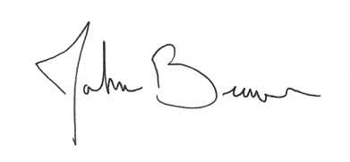

John F. Bruno, PhD

Professor